**IFT598: Middleware Programming & Database Security**

Arizona State University

M5A1

**Student**

Chih-Chieh Chang

**Professor**

Dinesh Sthapit

October 27, 2022

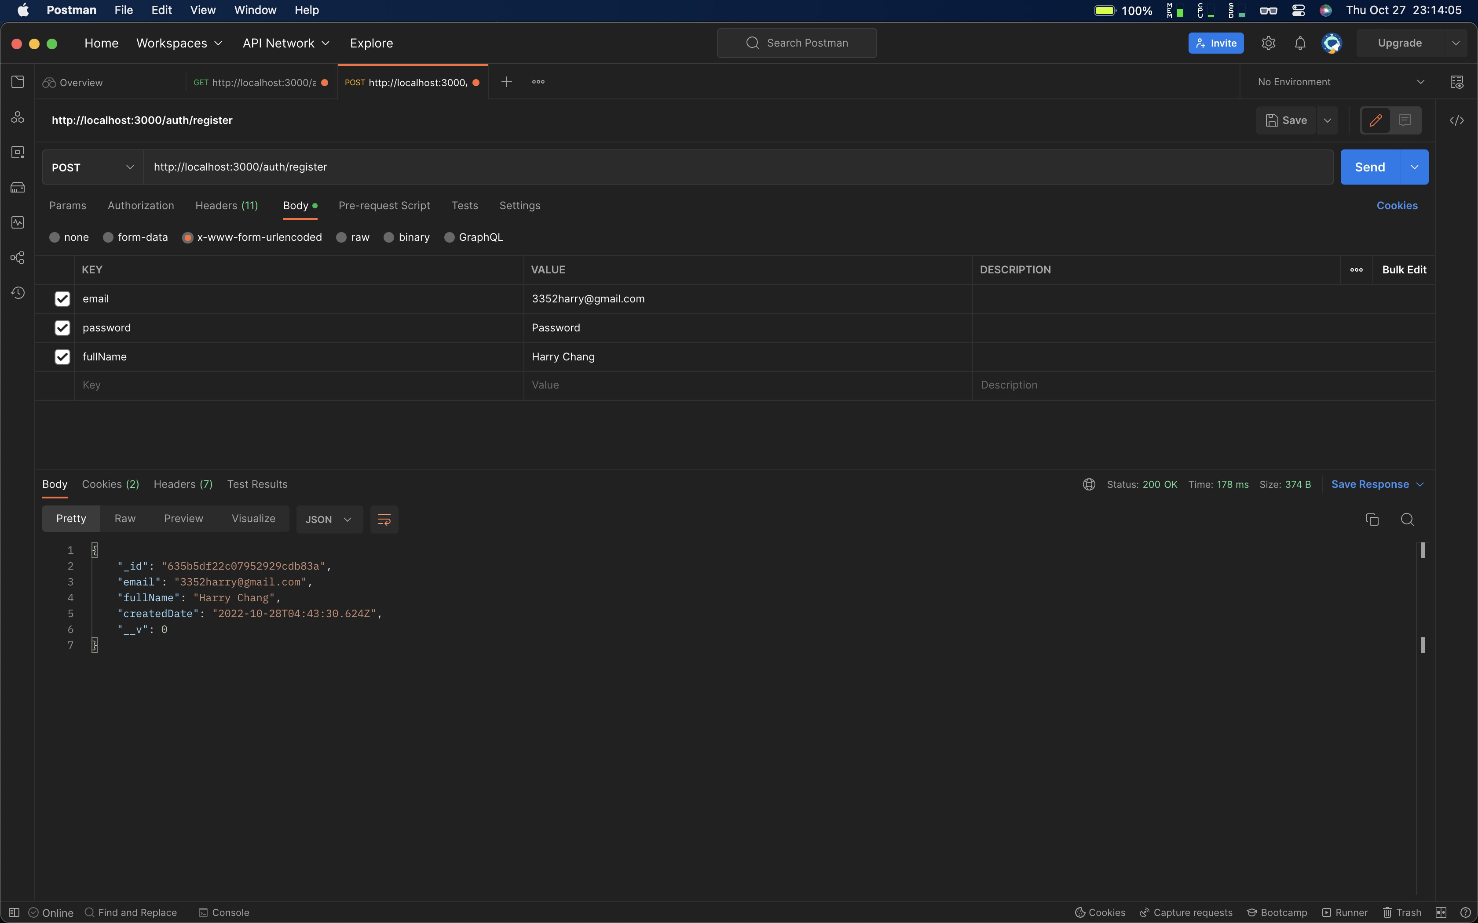

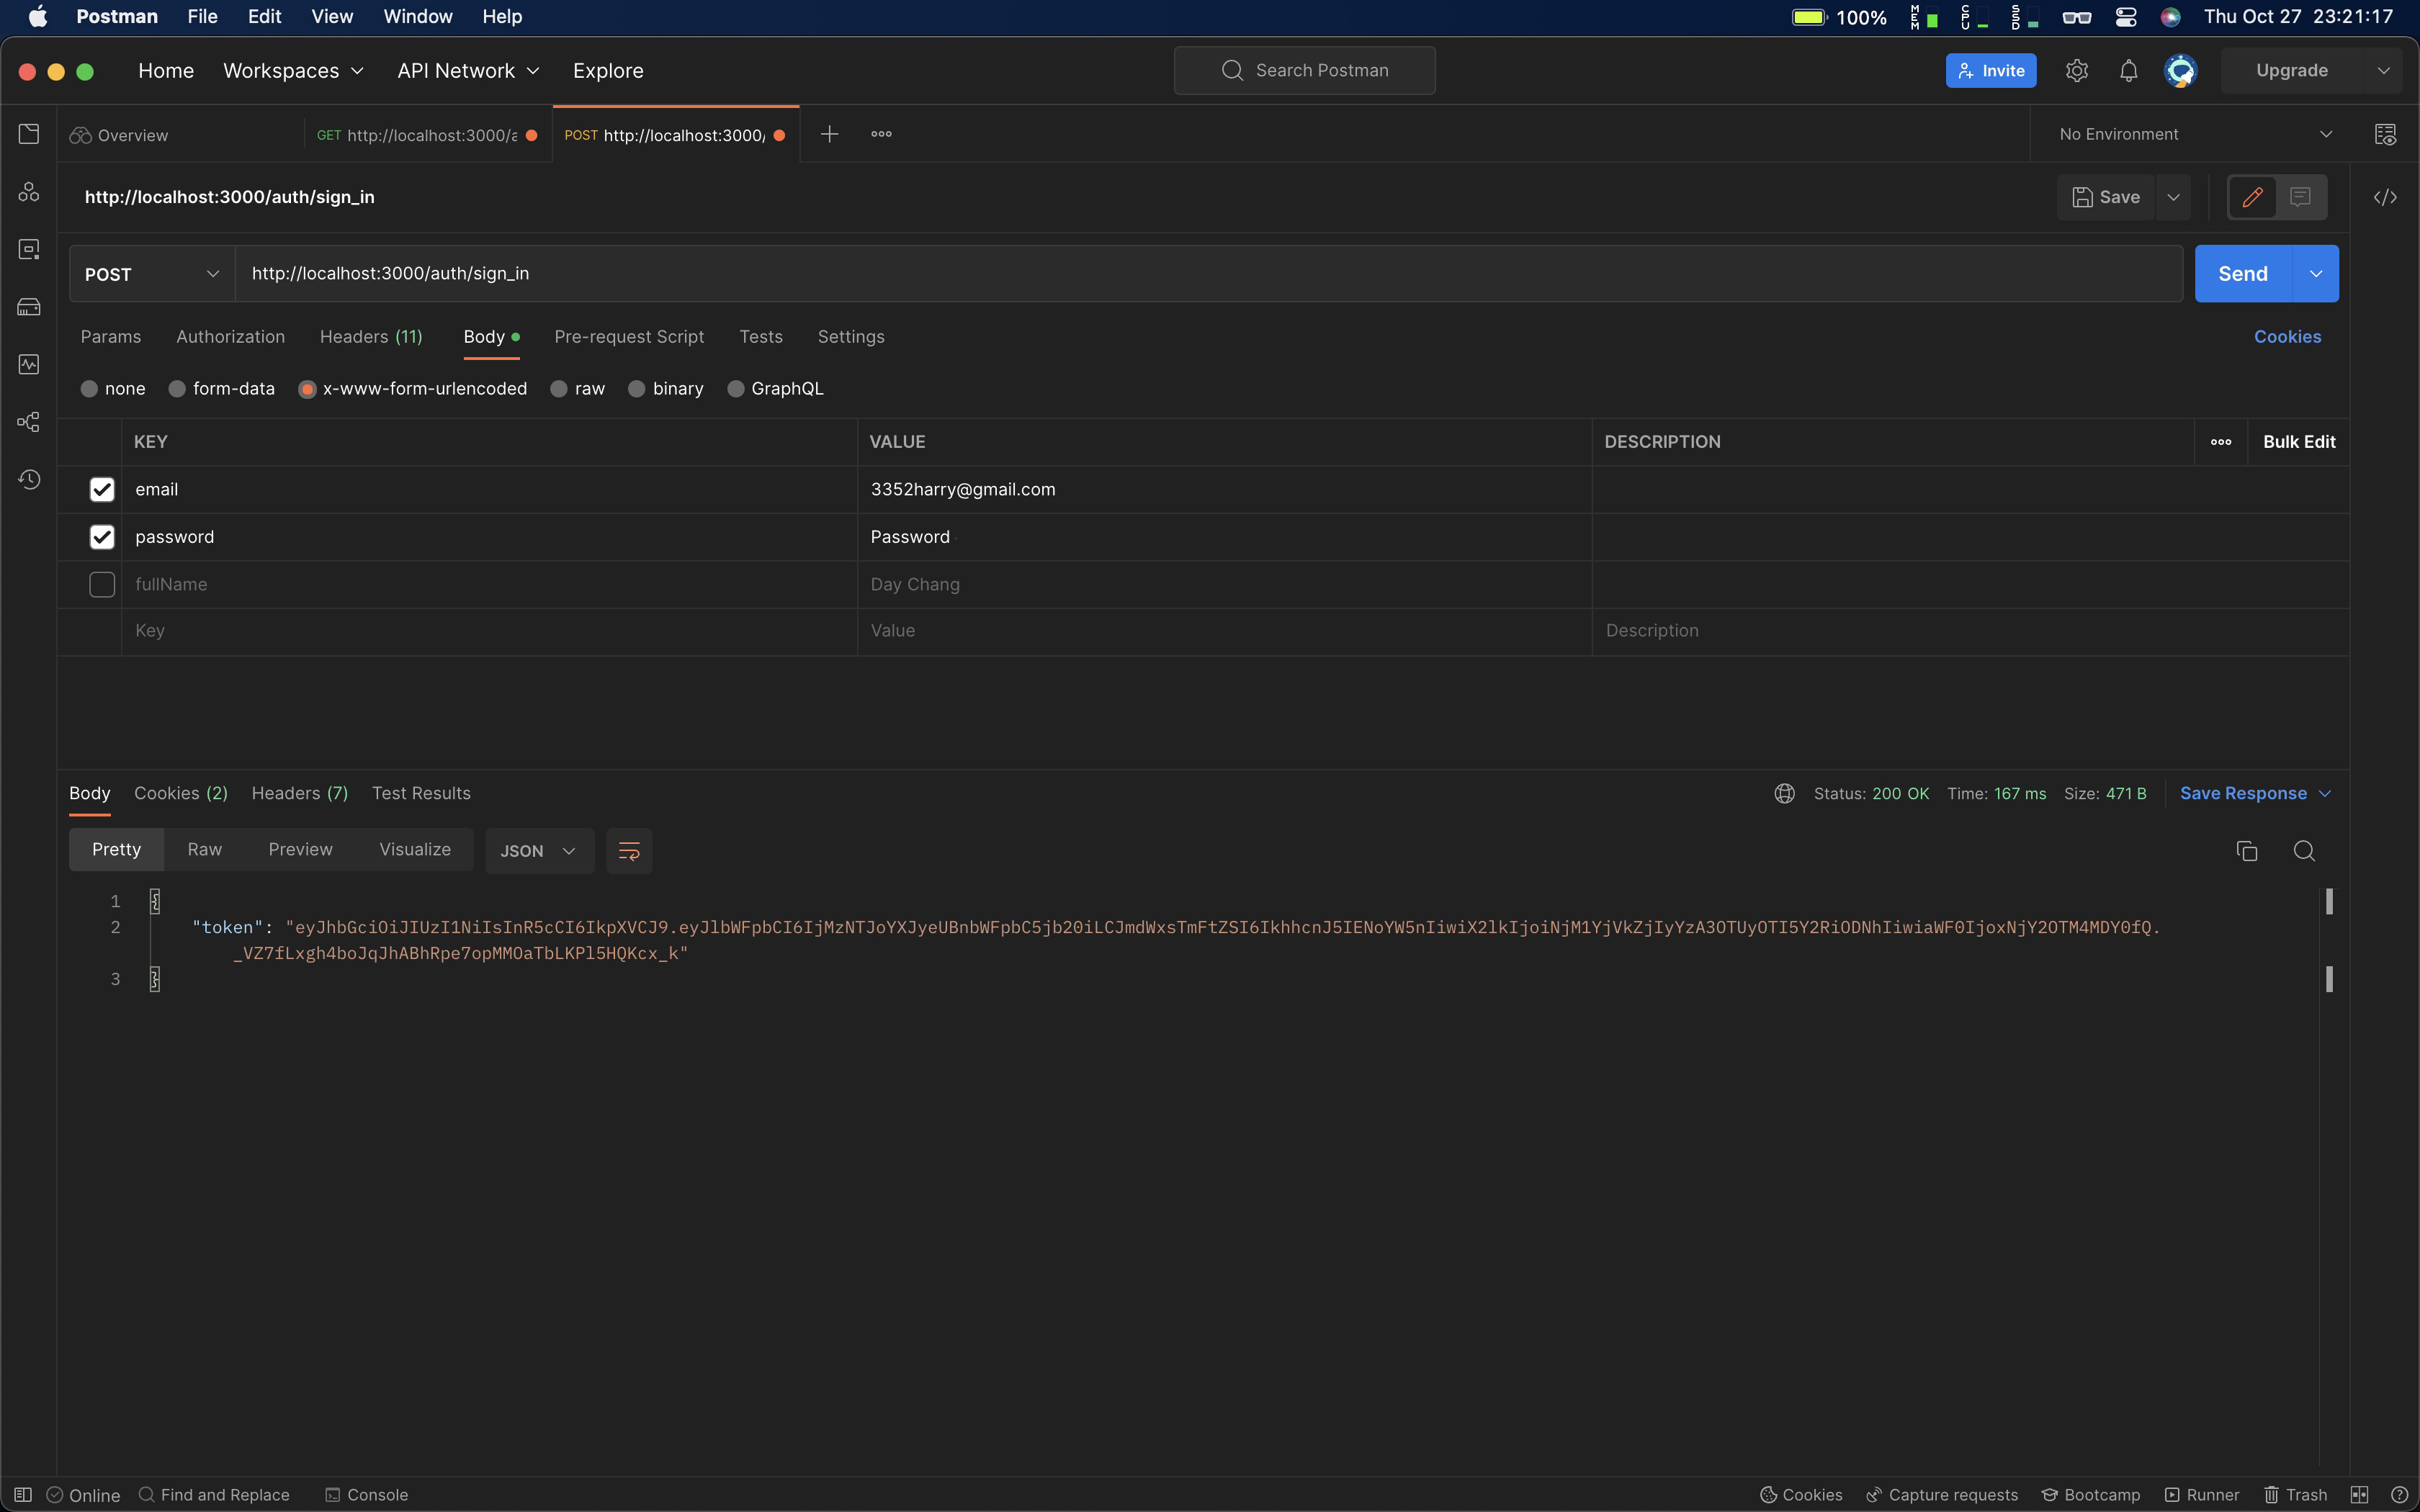

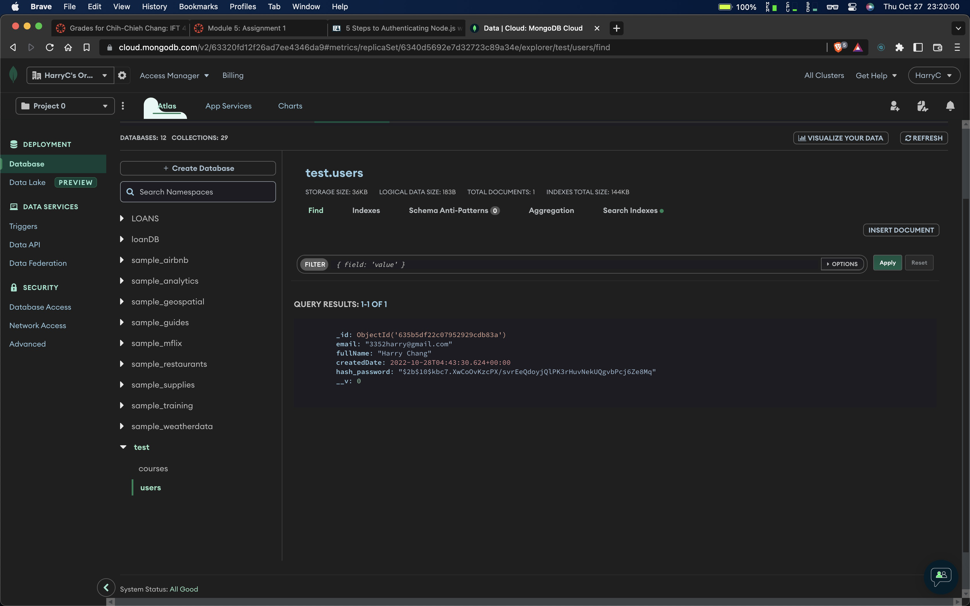

Something went wrong in my code..

**JWT Brief**

JSON web token (JWT), pronounced "jot", is an open standard ([RFC 7519](https://tools.ietf.org/html/rfc7519)) that defines a compact and self-contained way for securely transmitting information between parties as a JSON object. Again, JWT is a standard, meaning that all JWTs are tokens, but not all tokens are JWTs.

Because of its relatively small size, a JWT can be sent through a URL, through a POST parameter, or inside an HTTP header, and it is transmitted quickly. A JWT contains all the required information about an entity to avoid querying a database more than once. The recipient of a JWT also does not need to call a server to validate the token.

**Reference**

Auth0 (n.d.)

<https://auth0.com/docs/secure/tokens/json-web-tokens>